**Monton, Sean Paul M.**

**BSCS 1-1**

**Computer Programming 1 – Activity 6 (Meal Selection and Discount System – Without Order Time)**

**Output**

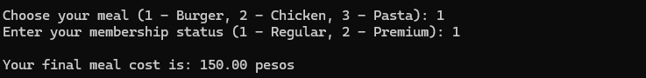

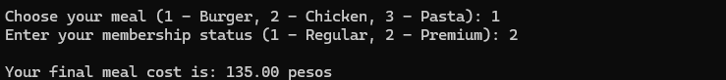

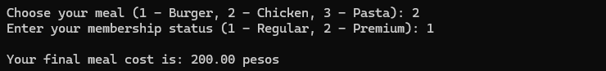

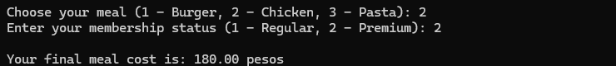

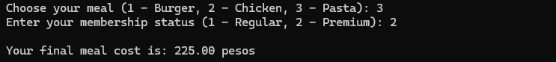

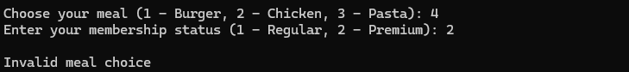

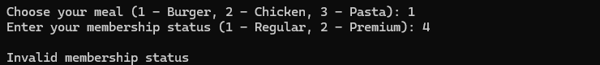

**Source Code**

#include <stdio.h>

int main() {

int meal_choice, mem_status;

float burger = 150.00, chicken = 200.00, pasta = 250.00;

printf("Choose your meal (1 - Burger, 2 - Chicken, 3 - Pasta): ");

scanf("%d", &meal_choice);

printf("Enter your membership status (1 - Regular, 2 - Premium): ");

scanf("%d", &mem_status);

printf("\n");

switch (meal_choice) {

case 1:

if(mem_status == 1) {

printf("Your final meal cost is: %.2f pesos", burger);

} else if(mem_status == 2) {

printf("Your final meal cost is: %.2f pesos", burger - (burger * .10));

} else {

printf("Invalid membership status");

}

break;

case 2:

if(mem_status == 1) {

printf("Your final meal cost is: %.2f pesos", chicken);

} else if(mem_status == 2) {

printf("Your final meal cost is: %.2f pesos", chicken - (chicken * .10));

} else {

printf("Invalid membership status");

}

break;

case 3:

if(mem_status == 1) {

printf("Your final meal cost is: %.2f pesos", pasta);

} else if(mem_status == 2) {

printf("Your final meal cost is: %.2f pesos", pasta - (pasta * .10));

} else {

printf("Invalid membership status");

}

break;

default:

printf("Invalid meal choice");

break;

}

return 0;

}